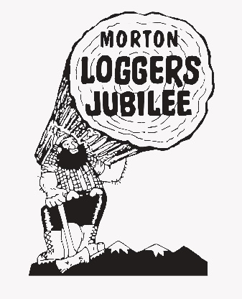
ALL WEEKEND EVENTS
31st Annual Flea Market
Food Concessions
80th Annual
Morton Loggers' Jubilee 2023
Sponsored by King Beverage, Budweiser,
and Port Blakely

Thursday August 10, 2023
67th Annual Queen Coronation
Morton High School - 8:00pm

ADMISSION PRICES
Friday Lawnmower Races Daily Logging Shows
Adults: $15 Seniors: $10 Adults: $10 Seniors: $8
Children (6-12): $5 Children (6-12): $5
Children 5 and under FREE Children 5 and under FREE

Friday August 11, 2023
Hampton Mill Tours
8:00 am – 1:00 pm
Lawnmower Races
Gates open at 4:30 pm
Time Trials 6:30pm
Racing 7:30pm
NO PETS IN ARENA
Saturday August 12, 2023
10K RUN, Morton High School, Registration - 7:00am, Run 8:00am
Jubilee Championship Bed Races on Main Street - 11:00 am
JUBILEE GRAND PARADE
THEME: “80 YEARS of MEMORIES”
11:30 am, Main Street
2023 JUBILEE LOGGING SHOW
Jubilee Arena - 2:00 pm
Gates open at 12:30 pm NO PETS IN ARENA
“The Addams Family” – Roxy Theater
7:00 pm
JUBILEE Saturday Night DANCE
Featuring: “STILL GOT IT!” www.stillgoitband.com
Gas Plus Parking Lot, TIME: TBA
Sunday August 14, 2023
2023 JUBILEE LOGGING SHOW
Jubilee Arena - 12:00pm
Gates open at 11:00 am
NO PETS IN ARENA
Visit us on our website…..www.loggersjubilee.com
LIKE us on ….

JUBILEE SPONSORS
